# Basic pitch

Quizlet used to be a very popular online application for studying notecards with a diverse way to study, an offline version with no ads, all the old features that quizlet removed such as gravity and matching, and with the ability to import old quizlet cardsets

# Core Features

## Quizlet intercompatibility

* Allows you to export card sets from quizlet to put them into offline quizlet
* Allows you to export card sets from offline quizlet so they can be imported to quizlet

## Gravity game

* <https://www.youtube.com/watch?v=SZ6rPsHrwcA>
* Similar ui/gameplay to missile command
* Some incoming challenges may be colored different to indicate they give a bonus, bonuses should be given out on words that previously were missed by the user to encourage them to learn the correct spelling/definition/whatever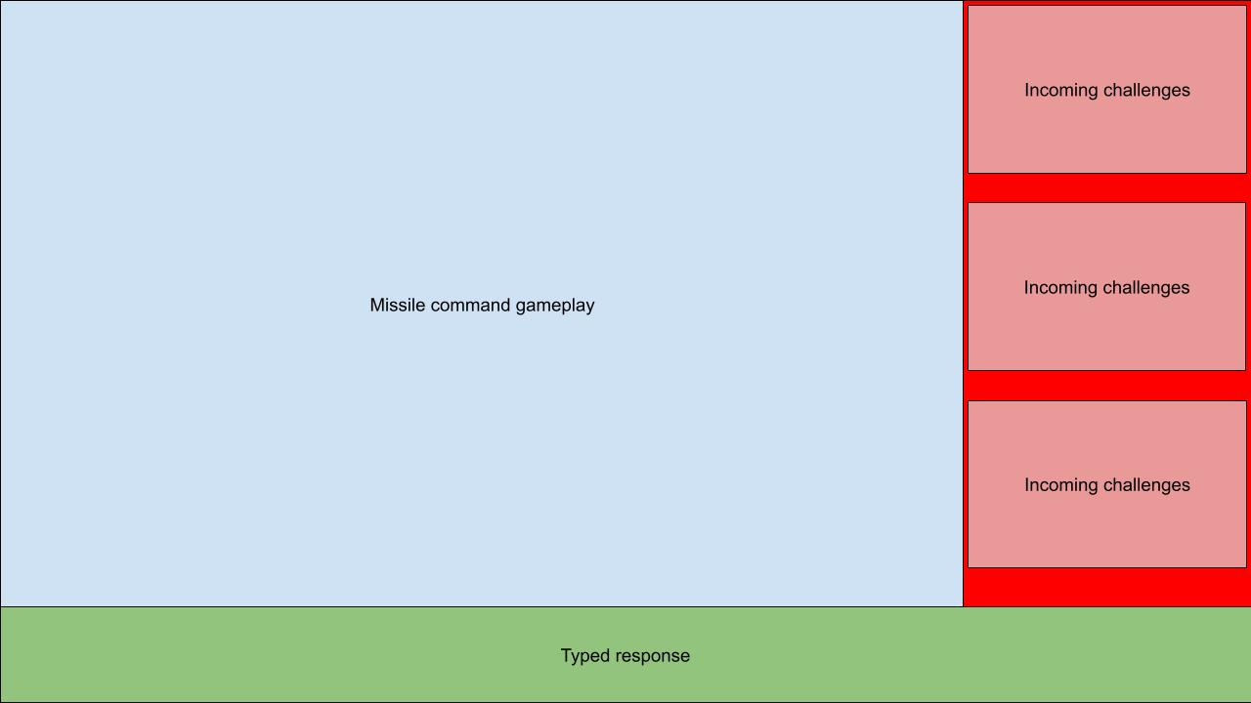

## Matching

## Making and saving sets

* UI idea for what it would look like to load/edit sets

## Basic flashcard mode

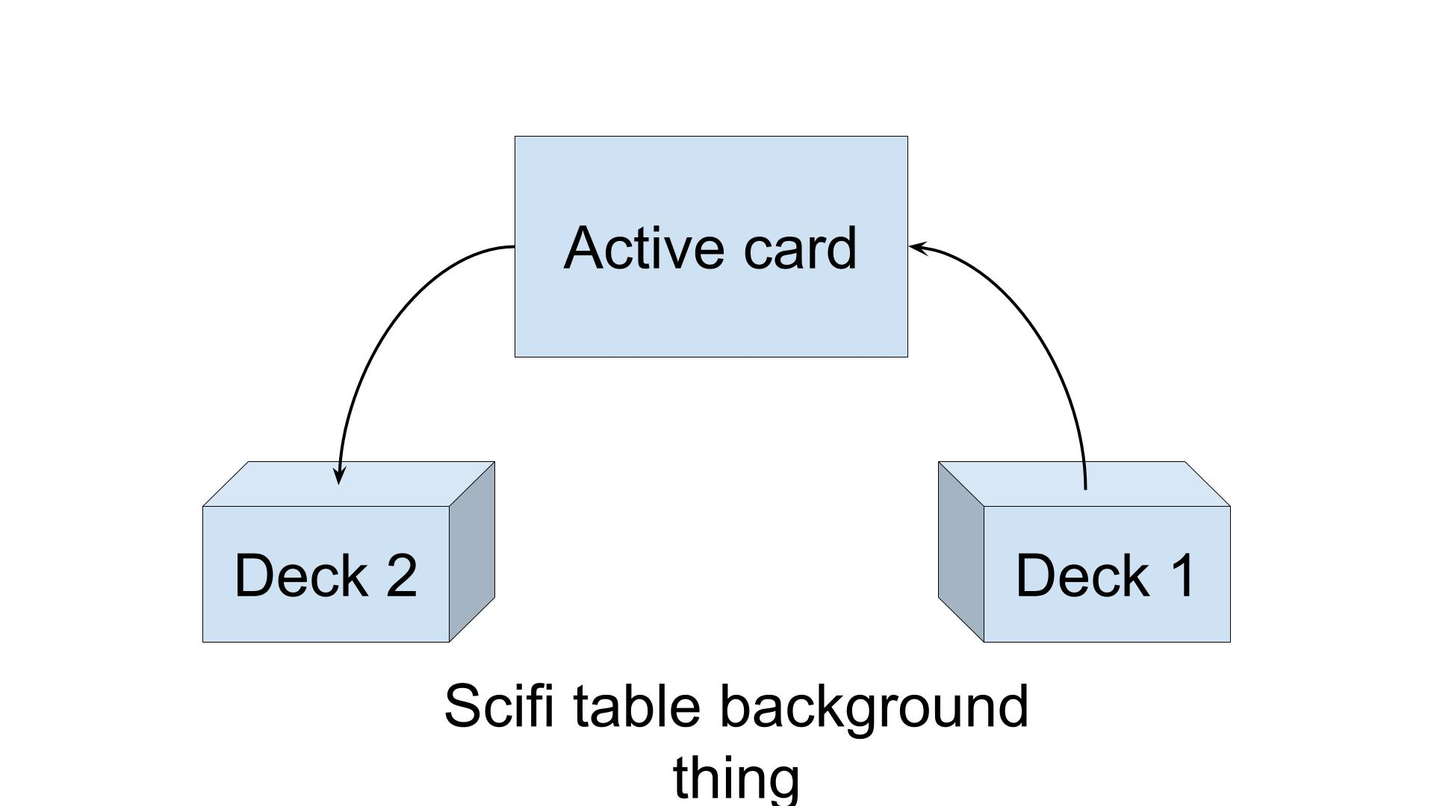

## Multiple choice tests

# Stretch features

## Vocab word search